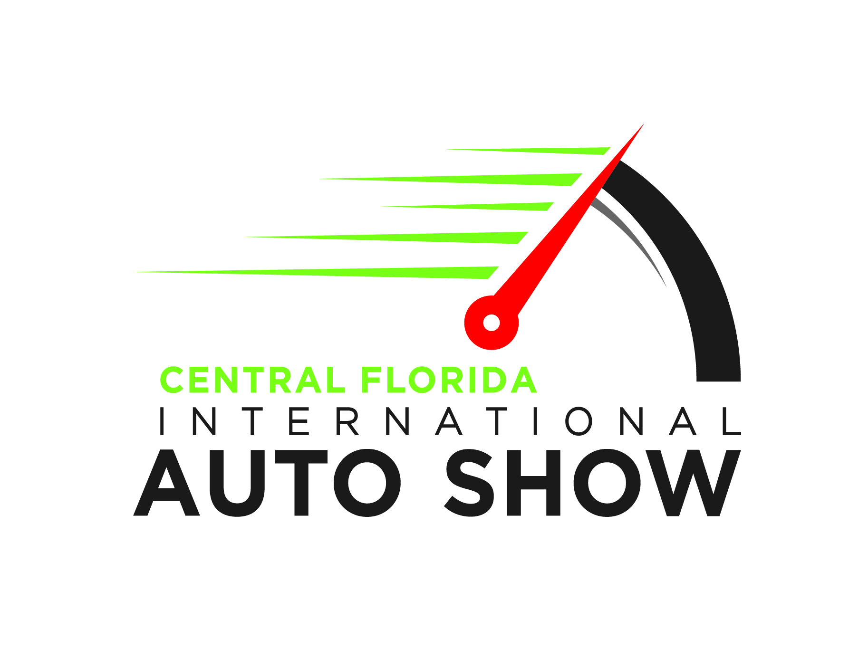

CALENDAR LISTING

2019-Model Central Florida International Auto Show
Races Into Orange County Convention Center Thanksgiving Weekend

WHAT:
The 2019-Model Central Florida International Auto Show is set to cruise more than 400 new cars, trucks, crossovers, SUVs and more into the Orange County Convention Center for Thanksgiving weekend. Everyone is invited to check out the latest models in a non-selling environment, sit behind wheels, inspect engines and even take a spin in dozens of new vehicles. The largest auto show in Florida, this annual event will also feature Camp Jeep and Ram indoor test drives, the latest electric vehicles, pre-production models and fun for the little ones. Additionally, the Festivals of Speed display will showcase nearly 100 ultra high-end exotic cars, motorcycles, luxury products and toys. Don’t miss unique display of rare Model A’s as well as the Antique Automobile Club of America’s collection of antique and collectible vehicles from the 1930s – 1970s.

WHEN:
Thursday, November 22, from 12 p.m. to 9 p.m. (Thanksgiving Day)
Friday, November 23, from 10 a.m. – 9 p.m.
Saturday, November 24, from 10 a.m. – 9 p.m.
Sunday, November 25, from 10 a.m. – 6 p.m.

WHERE:
Orange County Convention Center – North Concourse
9400 Universal Boulevard, Orlando, FL 32819

WHO:
Product specialists from leading automotive manufacturers will be at the show to answer questions and provide information on the latest vehicles. The Central Florida International Auto Show is owned and presented by the Central Florida Auto Dealers Association and produced by Motor Trend Auto Shows.

TICKETS:
Admission to the event is $10 for Adults, $5 for seniors (62 and older), military and first responders (w/any DOD or municipal ID) and students (under 21 w/school ID) and FREE for children 12 and under. Purchase advance tickets at www.AutoShowOrlando.com.

FOLLOW:
Follow www.facebook.com/OrlandoAutoShow, @OrlandoAutoShow on Twitter and @OrlandoAutoShow on Instagram. Hashtag: #OrlandoAutoShow

FOLLOW:
Follow www.facebook.com/OCAutoShow, @OCAutoShow on Twitter and @OCAutoShow on Instagram. Hashtag #OCAUTOSHOW

HI-RESOLUTION PHOTOGRAPHY:
For high-resolution photography needs, please contact Spin Communications, at 415/380-8390 or deedee@spinpr.com.

CONTACT:
DeeDee Taft/Shelbi Okumura
Spin Communications
415/380-8390, deedee@spinpr.com
# # #

